CS3413 – Assignment 1

Amir David

Dr. Kent

September 11th, 2019
David_Amir_AS1.c source code:
#include <stdio.h>
#include <string.h>
#include <stdlib.h>
#define CHARS 50
#define SIZE 20

int find_first(int arrival[], int duration[], int current_time);
void preempt(int z);

int main(){
char str[20];
char line[60];

int i;
for(i=0;i<4;i++){ //skip the header
scanf("%s",str);
}

char user[SIZE][20];
char process[SIZE];
int arrival[SIZE];
int duration[SIZE];
int count = 0;
memset(str, '\0', sizeof(str));
memset(user, '\0', sizeof(user));

while((scanf("%s",str))!=EOF){

strcat(user[count], str);
strcpy(line,str);
strcat(line," ");

scanf("%s",str);
process[count] = *str;
strcat(line,str);
strcat(line, " ");

scanf("%s",str);
arrival[count] = (*str - '0');
strcat(line,str);
strcat(line, " ");

scanf("%s",str);
duration[count] = (*str - '0');
strcat(line,str);
strcat(line, "\n");
count++;
}
//Totaling the total duration
int s, tt = 0;
for(s=0;s<count;s++){
tt+=duration[s];
}

//index of the first process to start
int find_first(int arrival[], int duration[], int current_time){
int first, s;
int e, initial;
if(count<=1){
return 0;
}else{
for(e=0; e<count; e++){
if(duration[e]>0){
initial = e;
goto FLAG;
}
}
FLAG:if(arrival[initial] != arrival[initial+1]){
first = initial;
}else{
int min = initial;
for(s=1; s<count; s++){
if((duration[s]!=0)&&(arrival[s] <= current_time)&&(duration[s]<duration[min])){
min = s;
break;
}
}
first = min;
}//end if
return first;
}//end if
}//end find_first

int remaining[count]; //array of remaining time of processes
for(s=0;s<count;s++){
remaining[s] = duration[s]; //populate remaining array with the duration value of elements
}
int z, u, current_time = arrival[0], all = 0;
printf("Time:\tJob:\n");
while(all<count){
if(current_time > tt){
printf("%d\tIDLE\n", current_time);
exit (0);
}
s = find_first(arrival, remaining, current_time);
HERE1:s = find_first(arrival, remaining, current_time);
for(i=0;i<remaining[s];i++){
if(remaining[s]>0){
printf("%d\t", current_time);
current_time++;
printf("%c\n", process[s]);
remaining[s]--;
for(z=0;z<count;z++){ //check for pre-emption
if((duration[z] < remaining[s])&&(arrival[z] <= current_time)){
goto HERE2;
} //end if
} //end for
}//end if
} //end for

HERE2:if(remaining[z]>0){
for(u=0;u<duration[z];u++){
printf("%d\t", current_time);
current_time++;
printf("%c\n", process[z]);
remaining[z]--;
for(z=0;z<count;z++){ //check for pre-emption
if((duration[z] < remaining[s])&&(arrival[z] <= current_time)){
goto HERE2;
} //end if
} //end for
} //end for
all++;
goto HERE1;
}//end if
}//end while
return 0;
} //end main

Screenshot:
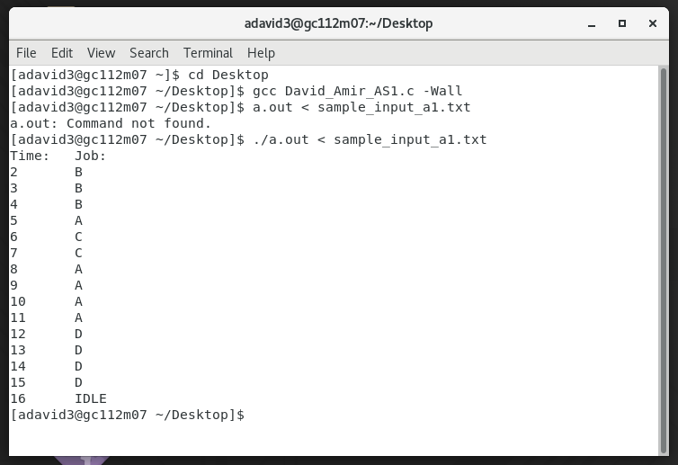
Note: When tested on a lab machine, the code sometimes needed to be recompiled/rerun to output correctly.

